CLOUD COMPUTING LAB



SUBMITTED TO
SIR WAQAS SALEEM & SIR SHOAIB
SUBMITTED BY
HAMNA MAHMOOD
2023-BSE-025
BSE V-A

Lab 12
Terraform Provisioners, Modules & Nginx Reverse Proxy/Load Balancer
Task 0 Lab Setup (Codespace & GH CLI)
- task0_codespace_create_and_list. Png
- task0_codespace_ssh_connected.png
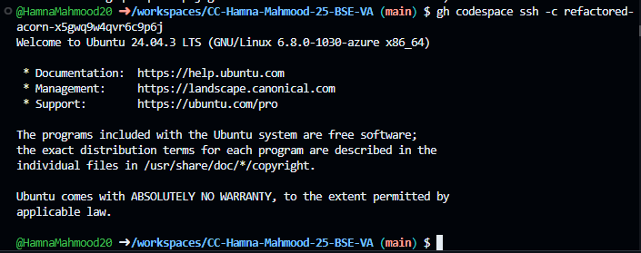
Task 1 – Organize Terraform code into separate files
- task1_project_directory.png
- task1_files_created.png
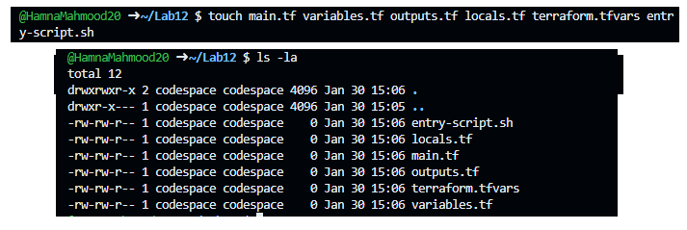

- task1_variables_tf.png
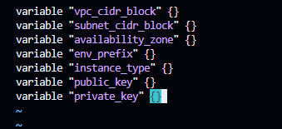
- task1_outputs_tf.png
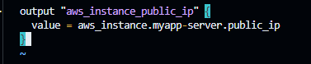
- task1_locals_tf.png
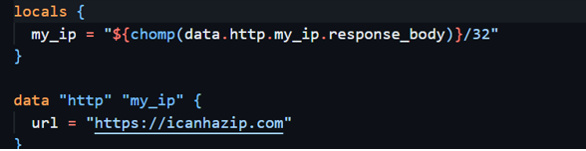
- task1_terraform_tfvars.png
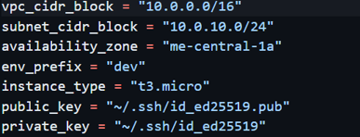
- task1_main_tf.png
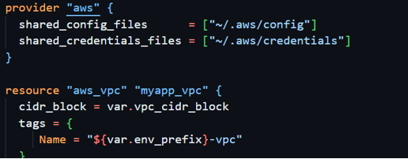
- task1_entry_script.png
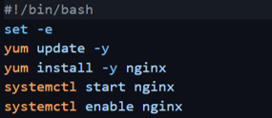
- task1_ssh_keygen.png
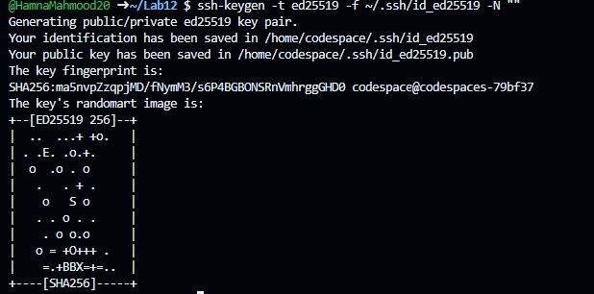
- task1_terraform_init.png
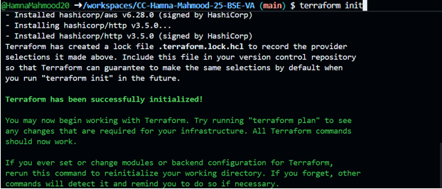
- task1_terraform_apply.png
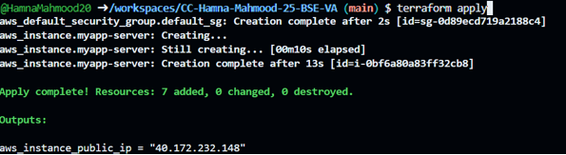
- task1_terraform_output.png
- task1_nginx_browser.png
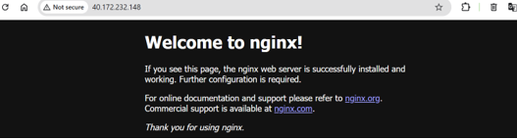

- task1_terraform_destroy.png
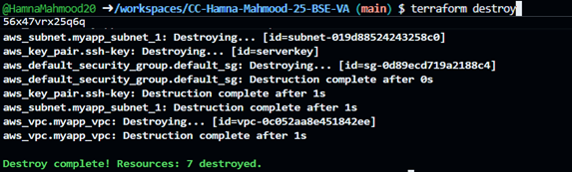
Task 2 – Use remote exec provisioner
- task2_main_tf_remote_exec.png
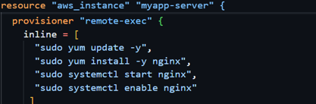
- task2_terraform_apply.png
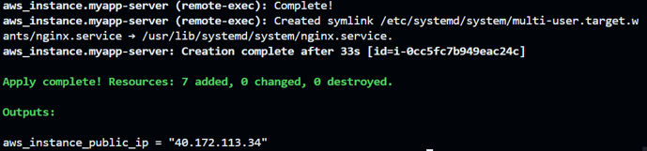
- task2_terraform_output.png
- task2_nginx_browser.png
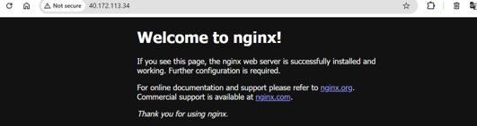
Task 3- Use file & local exec provisioner
- task3_main_tf_all_provisioners.png
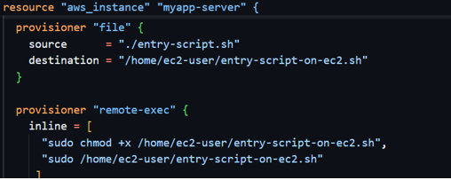
- task3_terraform_apply.png
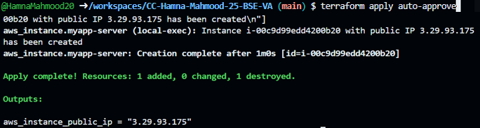
- task3_terraform_output.png
- task3_nginx_browser.png
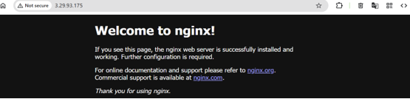
- task3_terraform_destroy.png

Task 4 - Create Terraform modules (subnet module)
- task4_module_structure.png
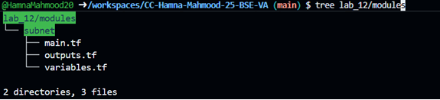
- task4_subnet_variables.png
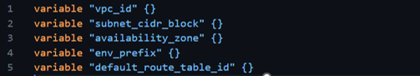
- task4_terraform_apply.png
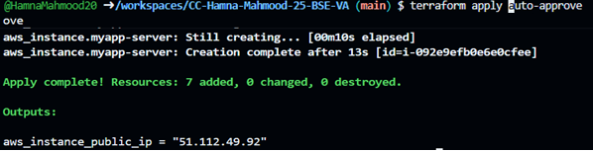
- task4_terraform_output.png
- task4_nginx_browser.png
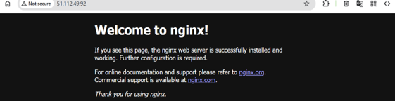

Task 5 - Create webserver module
- task5_webserver_module_structure.png
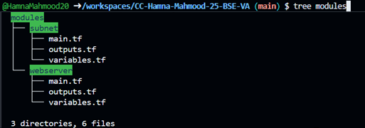
- task5_webserver_variables.png

- task5_webserver_main.png
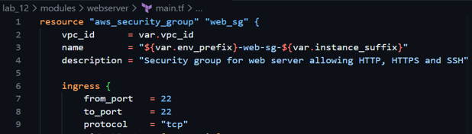
- task5_terraform_apply.png
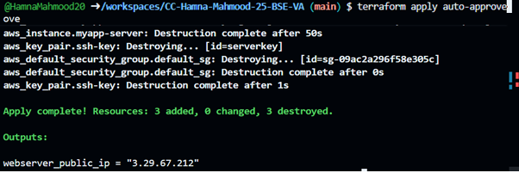
- task5_terraform_output.png
- task5_nginx_browser.png
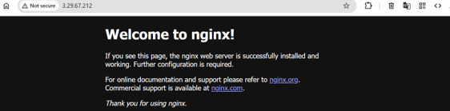
- task5_terraform_destroy.png
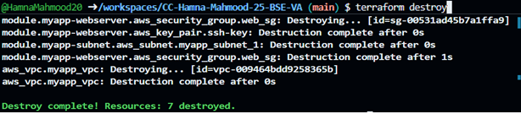
Task 6 - Configure HTTPS with self-signed certificates
- task6_entry_script_https.png
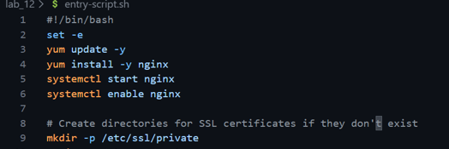
- task6_terraform_apply.png
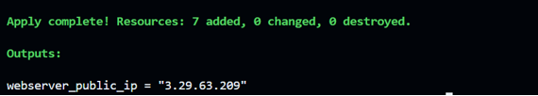
- task6_nginx_https_browser.png
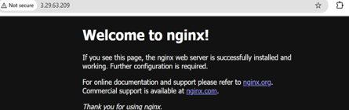
- task6_http_redirect.png
Task 7 - Configure Nginx as reverse proxy
- task7_apache_script.png
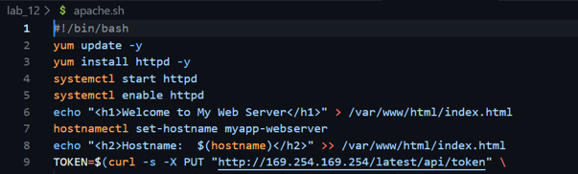
- task7_terraform_apply.png
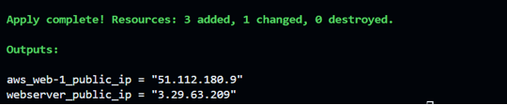
- task7_nginx_conf_reverse_proxy.png
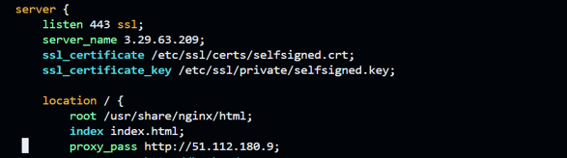
- task7_nginx_restart.png
- task7_mime_types.png
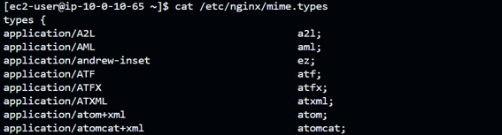
- task7_ssl_cert.png
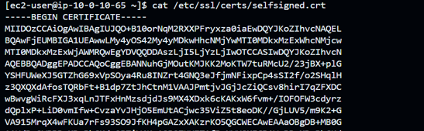
- task7_ssl_key.png
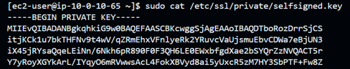
- task7_reverse_proxy_browser.png
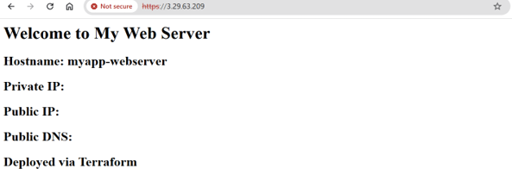
Task 8 – Configure Nginx as load balancer
- task8_main_tf_web2.png
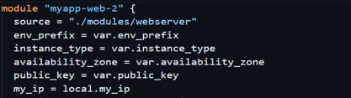
- task8_outputs_web2.png
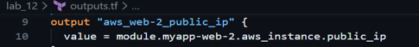
- task8_terraform_apply.png
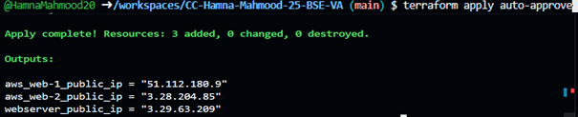
- task8_nginx_conf_load_balancer.png
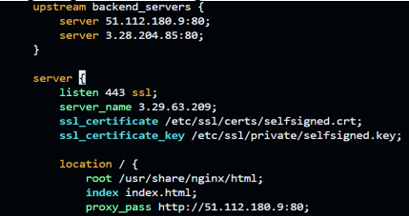

- task8_nginx_restart.png
Task 9 - Configure high availability with backup servers
- task9_nginx_conf_ha_web1_primary.png
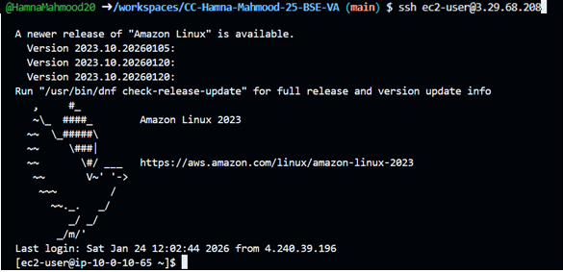
- task9_ha_web1_only.png
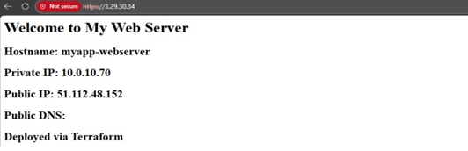
- task9_ha_web2_only.png
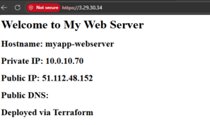

Task 10 - Enable Nginx caching
- task10_nginx_conf_cache.png
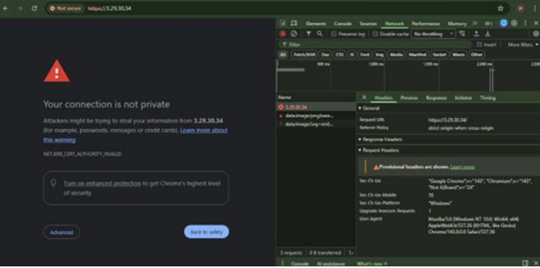

- task10_nginx_restart.png
- task10_cache_miss.png
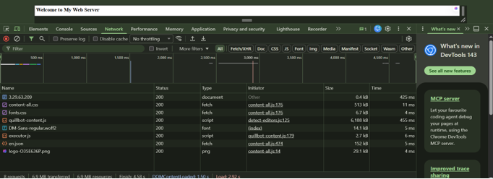
Cleanup
- cleanup_destroy_prompt.png
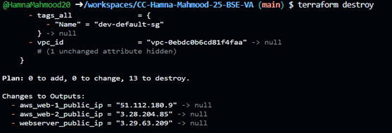
- cleanup_destroy_complete.png
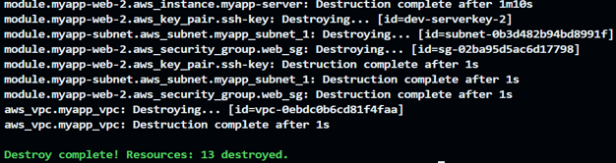
- cleanup_state_empty.png
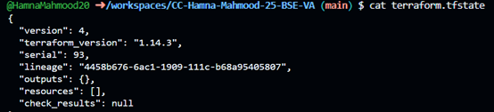
- cleanup_final_files.png
